Touch sensor Challenges

1. **Add a sensor to your robot!**

Use the construction instructions in the app to add a single touch sensor to your robot. Go to Robot Educator, build instructions, touch sensor for the instructions (or look in the book in the kit.

1. **Challenge 1**

**Program your robot to move straight until you tap the sensor with your hand.**

B

C



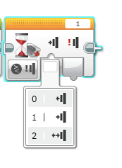

**Hint:** You will combine: Move Steering + Wait Block.

0 = released

1 = pressed

2 = bumped

Once complete and tested see the suggested solution. Did you do it the same way?

1. **Challenge 2**

**Program your robot to move until it hits the edge of a wall. Then back up and turn right 90 degrees.**

B

C

**Hint:** You will combine Move Steering + Turning + Wait Block

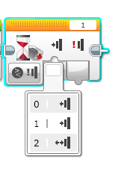

0 = released

1 = pressed

2 = bumped

Once complete and tested see the suggested solution. Did you do it the same way? Was your way better? Or is the suggested solution more efficient?