TASK 1 – PART A
To investigate the movement of the robot.
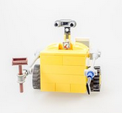
Syllabus Outcomes: MA4-1WM, MA4-2WM, MA4-3WM, MA4-4NA, MA3-9MG, MA4-15MG
Instructions: Seconds
- Set the robot to move forward for 3 seconds.
- Measure the distance travelled by the robot, in centimetres, in 3 seconds.

ANSWER:

- Showing all necessary working out, use appropriate mathematical calculations to determine how far the robot would move in:

a) | 1 second? | b) | 1 minute?
c) | 1 hour? | d) | 1 day?

Required Conversions:

 | ÷ 60 |  | ÷ 60 |  | ÷ 24
Seconds |  | Minutes |  | Hour |  | Day
 | × 60 |  | × 60 |  | × 24

Success Checklist:

1) | We set the robot for 3 seconds.
2) | We measured the distance travelled in 3 seconds and recorded it above.
3) | We calculated the distance travelled for the different times given above, showing all working out.

TASK 1 – PART B
To investigate the movement of the robot.
Syllabus Outcomes: MA4-1WM, MA4-2WM, MA4-3WM, MA4-4NA, MA4-5NA, MA4-15MG
Instructions: Seconds
- Estimate, in seconds, how long you believe it would take the robot to move forward 50cm.
ANSWER:

- Test your answer. How accurate was your estimate?

- If your estimate was incorrect, how long does it actually take the robot to move forward 50cm?

- What is the difference between the actual result and your estimate?

Success Checklist:

1) | We estimated the time we believe the robot would take to move forward 50cm, and recorded it above.
2) | We tested our estimate and commented on its accuracy.
3) | We calculated the time the robot takes to move 50cm.
4) | We found the difference between our estimation and the actual answer.

TASK 1 – PART C
To investigate the movement of the robot.
Syllabus Outcomes: MA4-1WM, MA4-2WM, MA4-3WM, MA3-9MG, MA4-7NA
Instructions: Seconds
- Choose any speed setting. Do not change it throughout Part C.

SPEED SETTING:

- Choose 10 different time settings and measure the distance travelled for each in centimetres. Record the results in the table below.

TRIAL | TIME (in seconds) | DISTANCE TRAVELLED ( in cm)
1
2
3
4
5
6
7
8
9
10

- Transfer your data into the Excel spreadsheet “Task 1 Part C”.

- In the Excel spreadsheet, create a Distance-Time graph to represent your data, by following the steps below:

- Highlight from cell B4 to C13.

- Insert a Line Graph – any 2D.

- Under ‘Chart Tools’:
- Add the chart title “Distance-Time Graph for Speed Setting _____”
- Add the axis titles: “Time” for horizontal and “Distance” for vertical.
- Turn off the Legend.

- Save ………

CONT / …..
- What do you notice about your graph?

- Compare your graph with another group who used a different speed setting. List the similarities and / or differences.

Success Checklist:

1) | We chose our speed setting and recorded it above.
2) | We performed 10 time trials, measuring the distance of each trial, and recorded it in the table above.
3) | We correctly transferred our data to the spreadsheet.
4) | We followed the steps provided to create a line graph for our data.
5) | We saved our file correctly.
6) | We wrote about 2 or 3 features of our graph in the space provided above.
7) | We compared our results with another group and recorded our findings in the space provided.

TASK 1 – PART D
To investigate the movement of the robot.
Syllabus Outcomes: MA4-1WM, MA4-2WM, MA4-3WM, MA3-9MG, MA4-4NA, MA4-5NA,
MA4-18MG
Instructions: Rotations
- A rotation indicates one full turn made by the wheel of the robot. In Mathematics, what type of angle shows a full turn and how many degrees is this angle?

NAME: NUMBER OF
DEGREES:

- Leaving the “steering” on , measure the distance travelled (in mm) when the robot moves ONE (1) full rotation.

ANSWER:

NOTE: This distance actually indicates the perimeter of the wheel (the distance around the boundary of the wheel).

- Using a mathematical calculation, how far would you expect the robot to move if the wheel makes the following rotations:

a) | 0.5 turn? | b) | ¼ turn? | c) | 5 turns?

- Using a ruler, measure the diameter (in mm) of the wheel.
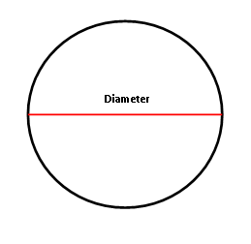

ANSWER:

- In a circle, what is the name of half the diameter?

ANSWER:
- Showing your working out, divide your distance travelled (Q2) by the diameter of the wheel (Q4).

ANSWER:

- Did you get an answer close to 3.14?

DID YOU KNOW: When you divide the perimeter of a circle (we say its circumference) with its diameter, you will always get 3.14159….. . This number is known in Mathematics as Pi and we write it as π.

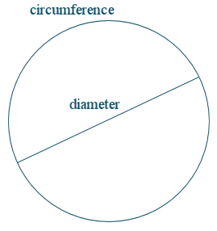

$$π= \frac{Circumference}{Diameter}$$

Success Checklist:

1) | We correctly named an angle that moves in one full rotation and its size.
2) | We measured how far the robot moved in one full rotation.
3) | We calculated the distance travelled by the robot in the given rotations.
4) | We measured the diameter of the wheel.
5) | We found the name of half of a circle’s diameter.
6) | We calculated distance travelled ÷ diameter, showing full working out.
7) | We compared our results with the answer provided.

