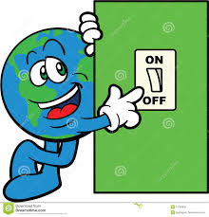
Switches Challenge 1
Challenge: Write a program that changes the display based on if the touch sensor is pressed or not pressed.
If pressed, your EV3 is happy! Display a smiley face. If not pressed, the EV3 is sad! Display a sad face.
Hint: You will need to use the display block, loops and switch blocks!
Switches Challenge 2

Can you write a program that display big eyeballs if you touch it once and a sad face if you touch it a second time and toggles back and forth.

