Worksheet: Senses vs Sensors
Preview Questions:-
- What sensors or senses do we humans have?
__________________________________________________________________________________
__________________________________________________________________________________
__________________________________________________________________________________
- Describe how any two of the sensors you listed above work.
__________________________________________________________________________________
__________________________________________________________________________________
__________________________________________________________________________________
__________________________________________________________________________________
- Give examples of sensors in robots that are similar to human senses.
__________________________________________________________________________________
__________________________________________________________________________________
__________________________________________________________________________________
Open and Read the How do Human Sensors Work Powerpoint
Label the following Diagrams

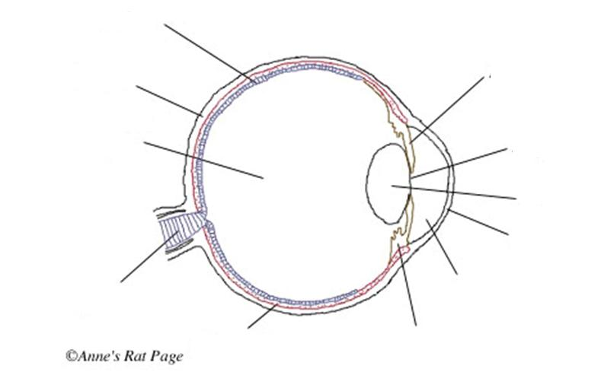
- Create a flow diagram of how the eye works.

- Label the following diagram.
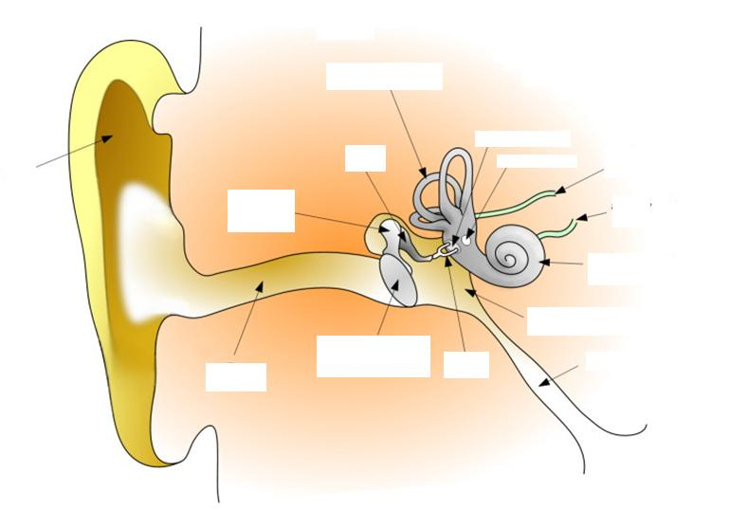
Visit this site
https://www.amplifon.com/web/uk/interactive-ear/index.html
- Aside from hearing what else do the structures in the inner ear do for us?
https://www.youtube.com/watch?v=YMIMvBa8XGs&vl=en
__________________________________________________________________________________
__________________________________________________________________________________
- Which part of the nervous system is the sense of touch attached to?
__________________________________________________________________________________
__________________________________________________________________________________
- What kind of stimuli can your sense of touch detect?
__________________________________________________________________________________
__________________________________________________________________________________
Robot Sensors
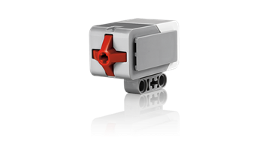
1. Look at the picture of the sensor and identify its name:
Picture | Name
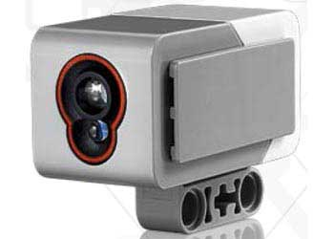
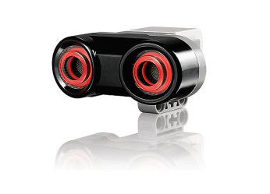
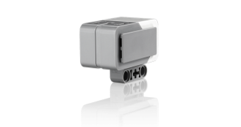

2. For each sensor, outline the main features and what their function is.
Sensor Name | Features and function

3. For each sensor , describe an example of a scenario when it could be used with a lego robot.
Sensor Name | Example of when it could be used

