Task 3
Testing the capabilities of your robot
Syllabus Outcomes: MA4-1WM, MA4-2WM, MA4-3WM
Instructions:
- As a class test the maximum weight that can be lifted by the mobility chair before it fails. Record your findings below.

- Identify a function of your robot which is measurable.

e.g: | - If your robot lifts a weight, you can measure its lifting capabilities.  - If it pulls a load, you can test what maximum load it can pull.

- Design a test that will test the abilities of your robot. Outline the details of your experiment, including:
AIM, HYPOTHESIS, SAFETY, PROCEDURE, RESULTS, CONCLUSION,
DISCUSSION

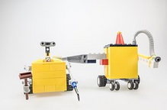

Success Checklist:

1) | As a class, we tested the maximum weight of the mobility chair.
2) | We identified the measurable function of our robot.
3) | We conducted an experiment to test this function.
4) | We have written our experiment using the proper procedure, including the conclusion of our experiment.

