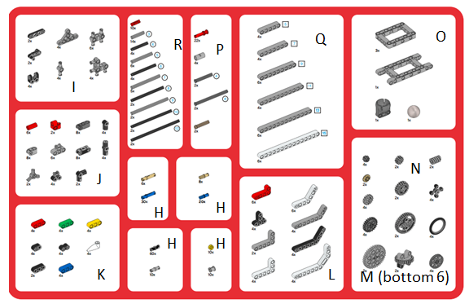
Note: Set Q has components 1-6, Q1 is the shortest and Q6 is the longest.
R1-10 also goes from smallest to largest.

