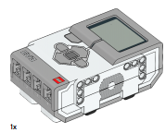 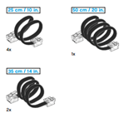 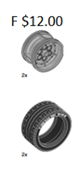 

A $120

B $8.50

D $17.50

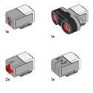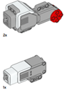 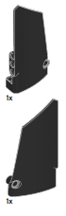 

E $6.50

C $37.25

S $0.30 note that this is one part of

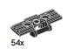

**Note**: that this is 1 part of the tank tread  
(or caterpillar track)